Covid-19 pandemic and aerosols’management in dental practices:
A personal contribution
25 April 2020

Prof. Eric Rompen
Liège, Belgium
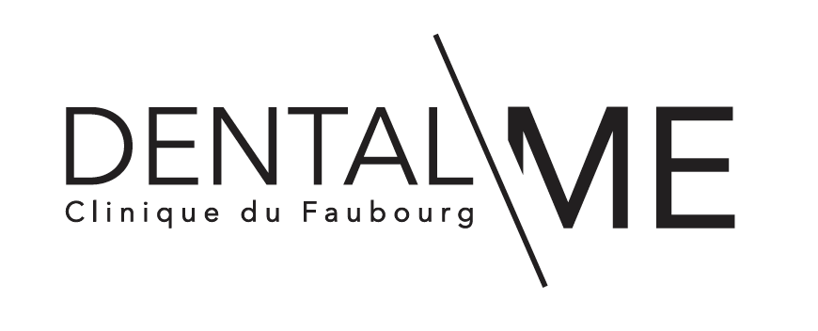

The present world crisis induced by the dissemination of the Coronavirus SARS-CoV-2 has stopped all non-urgent dental activities in most countries.

The question is now to describe and apply protocols that will be effective to protect ourselves and our medical staff, but also to avoid cross-contamination and consequent infection of patients, once we will be allowed to re-start our clinics.

I do not think it is useful to focus here on general and consensual measures to apply in the waiting room (social distancing, limitation of patient’s number, mask wearing, avoid shaking hands, …), to protect the staff (frequent hand washing/disinfection, FFP2/FFP3 masks + face shields during procedures, …), etc.

I would rather like to highlight 2 points, rarely underlined in presently circulating protocols:

- The simplest method to strikingly reduce the risk of cross-contamination, as taught in all good dental schools, is to increase the mean length of the appointments: if this mean length is doubled, then the risk of cross-contamination of patients and dental staff is simply divided by two.
At the same time, the negative financial impact of the time-consuming cleaning /disinfecting procedures is also cut in two.

- Dental aerosols:

- On the one side, SARS-CoV-2 is a respiratory virus, very different from the viruses we have been accustomed to handle, such as HIV, Hepatitis B and C.
This means that, for a cross-contamination to occur, the virus does not need to enter a wound, but a simple air transmission is possible, just like with viruses responsible for a cold (nasopharyngitis) or a flu.
But with potentially much more severe consequences.

For the German association for hospital hygiene, coughing, singing or simply speaking are the main sources of viral spreading. This suspicion is confirmed by a letter of the American National Academy of Science to the White House suggesting that the coronavirus could stay in the mist formed during breathing.
Floors contaminated by patients in Chinese hospitals could be the source of new aerosols due to floor cleaning or displacement of staff.

In a paper of the New England Journal of Medicine (March 2020), the virus was found viable in experimental aerosols for several hours.
The same paper described the survival of the virus for up to 3 days on hard surfaces, such as metal or plastics.

- Given that a high proportion of SARS-CoV-2 positive patients will have no or very discrete symptoms, and that symptomatic patients are infectious several days before the appearance of the symptoms and potentially also quite long after their disappearance, all patients have to be considered as potentially infectious.

- This is the reason why the wearing of masks is recommended in the waiting room for patients and secretarial staff.

- Once the dental treatment is about to start, the mask is obviously removed, and the patient potentially becomes the source of a micro-droplets cloud.

- On the other side, dentistry is characterized by the production of very powerful aerosols through the use of ultrasonic scalers, of air/water syringes and of rotary instruments with air or air/water cooling.
The cloud of micro-droplets that is then created is contaminated by the microflora of the mouth and upper respiratory tract.

This is a very unique situation: not only the patient wears no mask and has the mouth wide open, but its oro-pharyngeal microflora is powerfully dispersed outside by some dental treatments.
It has been shown (Micik et al., 1969) that dental aerosols create splatters with particles > 50 μm, which have a ballistic behavior and will directly pollute the surfaces facing the patient (unit’s tray, floor) on a distance of 0.5 to 2 meters.

But the dental aerosols also produce a cloud of micro-droplets < 1 μm, which will stay suspended in the air and can potentially directly penetrate the lungs.
This cloud of micro-droplets is highly contaminated by oro-pharyngeal microflora (Dutil et al. 2009; Hallier et al., 2010; Kobza et al. 2018), and recent studies have shown that SARS-CoV-2 may remain viable in comparable aerosols for up to 3 hours (van Doremalen et al, 2020).

Recent works (https://www.youtube.com/watch?v=LLzMDvzWeV8&feature=youtu.be) on these clouds of micro-droplets show that they can stay in suspension for long periods of time and spread on long distances.

- For our dental offices, this means that once an aerosol in a coronavirus-positive patient (often non symptomatic, see above) has been produced, the room’s air itself may potentially be infectious for the staff and the next patient.

- This cloud of micro-droplets will progressively deposit on all surfaces in the dental office, including the floor.

- In order to reduce the risk of cross-contamination, significant efforts have therefore to be made to decontaminate the atmosphere and all surfaces before treating the next patient.

Measures to reduce the risk of cross-contamination due to aerosols :

- Reduce aerosol formation/contamination during treatment:

  - Only treatments using ultrasonic scalers, air/water syringes or rotary instruments with air or air/water cooling are producing aerosols.
Manual scaling/root planning, dental extractions, implant placement, … for instance, are at lower risk.

  - It has been shown (Kampf et al., 2020) that hydrogen peroxide (H²O²) at 0.5 % for 1 minute is effective to kill the virus., as well as povidone iodine. A moutwash with 1 % H²O² for 1 min. or with Isobetadine can therefore be recommended before starting a dental procedure.
Please note that Chlorhexidine has only little or no effect on coronavirus.

  - High speed aspiration during aerosol-creating procedures can significantly (up to 90%) reduce aerosol’s power, but not suppress it. Attention: please check where the aspired air is rejected ! (see below)

  - The use of a dental dam, when clinically indicated, can increase aerosol’s power, but reduce its microbial contamination.

- Reduction of air contamination:

Various methods of continuous air disinfection/purification exist.

  - Ventilation systems with HEPA filters are effective in reducing virucidal load in the air (SARS-CoV-2 has a size of 0.1 μm, but since it is transported by micro-droplets, it is efficiently stopped by HEPA filters which have a 0.3 μm pore size), but the filters themselves can become highly infected.

  - Ventilation systems that combine filters (ideally HEPA ones) with UV sterilization of the filtered air seem the most effective in decontaminating the atmosphere.
Multiple papers (see below) have shown that UVs at sufficient doses are highly effective in destroying RNA of viruses, including corona ones.

  - Attention 1: ventilation systems do not have an immediate effect and need some time to totally decontaminate the air of a room (15 to 30 min.) after last aerosol’s production, which varies depending on the flow rate (m³/h) of the device and the volume of the room.
(The needed time is always longer than the simple calculation room volume/device flow, since clean air is re-injected in the room and mixes with non-clean air)

  - Attention 2: No ventilation system is able to decontaminate the surfaces (lighting system, XRay apparatus, unit’s tray, instruments’ whips, …) and the floor !

- Decontamination of surfaces/floor:

  - Misting of hydrogen peroxide + colloidal silver (Nocospray) can be effective in disinfecting surfaces, but:

    - It does not provide air decontamination
    - It cannot be used concomitantly with air decontamination systems by ventilation + filters/UVs.
    - If the diffusion time is only 3 minutes, the needed contact time is: 30 minutes for daily disinfection
60 minutes for curative treatment (i.e. after last aerosol) !
- Staff cannot stay in the room

This system therefore hardly seems integrable in a routine protocol aiming at reducing Covid-19 cross-contamination.

  - Manual cleaning/disinfection of all surfaces:

    - A strict checklist has to be applied no to forget any surface
    - This procedure is highly time- (10-15 min. minimum), and human resources-consuming ! But it can be performed while ventilation decontaminating systems are working.
    - Floors ??: they are contaminated by aerosols, and it has been suggested that staff displacements can re-suspend infectious particles in the air.
Meanwhile, they are rarely (never ?) cleaned in between patients …
    - Since SARS-CoV-2 is sensitive to soap, detergents, ethanol, aldehydes, …. most routinely-used surface disinfectants will be effective. Please follow the instructions for use of your specific product.

- Air + surfaces sterilization:

Presently, the only method that allows to decontaminate or even sterilize air and surfaces (including floors) seems to be direct irradiation with UV light.

This is the method of choice, when available, for disinfection of hospital rooms after Covid patients, and of public transportation.
It can be combined with continuous ventilation decontaminating systems.

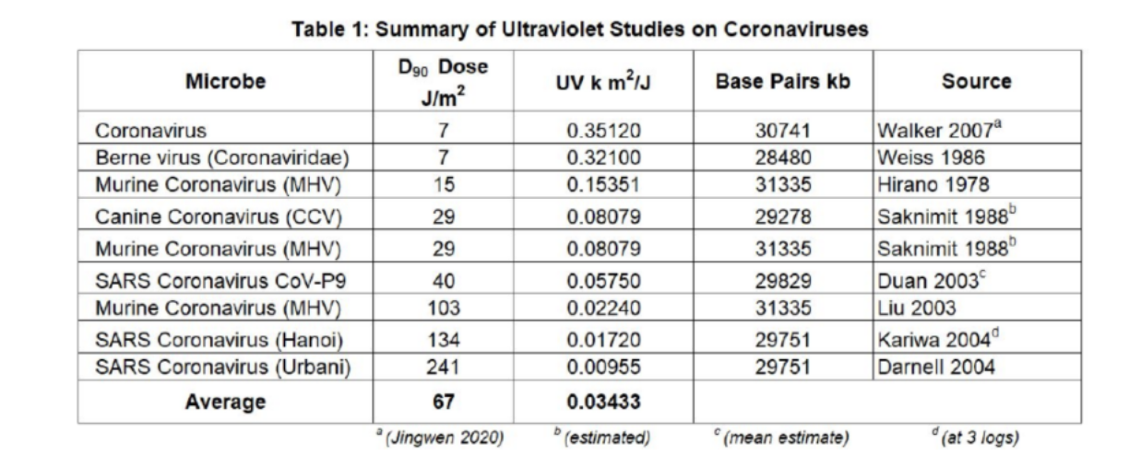
Numerous data demonstrating that UV irradiation is effective at denaturing corona viruses’ RNA are available:
Unfortunately, to date, our market search did not identify UV sterilization systems well adapted for dental offices (the presence of the central dental chairs requests at least 2 UV lamps on each side, or a mobile UV-unit), except some UV-robots at very high price.

Once UV devices designed for dental rooms at affordable price will be made available, they could become the gold standard for highest-level and fastest (5-10 minutes) complete (air/surfaces/floor) decontamination of the operating room after aerosol-forming procedures.

Additional points of attention:

- Air compressors:

Practitioners have to check if their compressor is pumping either fresh air from the outside, or air from a room: in the latter case, to avoid sending contaminated air in the dental offices, a HEPA filter should be adapted on the compressor.

- Aspiration systems:

The air aspired by the high speed aspiration system to reduce the potentially infectious aerosol’s spreading, is then rejected elsewhere by the aspiration machine.
Practitioners therefore have to carefully check the architecture of their installation !
  - If the air is rejected outside: OK.
  - If the air is rejected inside the building: either an air decontamination system (UV ventilation) has to be placed in the room where the air is rejected, or a HEPA filter should be adapted to the air rejection pipe.

- HVAC systems:

Clinicians should check how the ventilation system of the building has been set, since it is known (Li et al., 2007) that the micro-droplets from aerosols can be transported through the ventilation systems.
If the air is aspired (negative pressure) and expelled outside: OK.
If a positive pressure is applied, the air is most often expelled from the dental room towards the common areas. This can mean distributing the created dental aerosols in the entire clinic.
Solution: ??

- Architecture of the clinic:

The architecture of the clinic can induce problems that are very difficult or impossible to solve:
An open architecture with no physical partition of the different offices makes it possible for infectious dental aerosols to travel from one dental chair to the whole open structure.
This is sometimes true in modern clinics, where solutions can possibly be found on a case-by-case basis.
It is even more often the case in some hospitals or dental schools’clinics, in which multiple dental chairs are sometimes gathered in open spaces.
The control of the circulation of the clouds of micro-droplets seems impossible in those open areas.
The continuation of dental treatments is such large open spaces in the present times of Covid-19 pandemic should therefore be debated.

References:

Doremalen, Neeltje van, Trenton Bushmaker, Dylan H Morris, Myndi G Holbrook, Amandine Gamble, Brandi N Williamson, Azaibi Tamin, et al. 2020. “Aerosol and Surface Stability of SARS-CoV-2 as Compared with SARS-CoV-1.” The New England Journal of Medicine, 2020. https://doi.org/10.1056/NEJMc2004973.

Dutil, Steve, Anne Meriaux, Marie-Chantale de Latremoille, Louis Lazure, Jean Barbeau, and Caroline Duchaine. 2009. “Measurement of Airborne Bacteria and Endotoxin Generated during Dental Cleaning.” Journal of Occupational and Environmental Hygiene 6 (2): 121–30. https://doi.org/10.1080/15459620802633957.

Hallier, C, D W Williams, A J C Potts, and M A O Lewis. 2010. “A Pilot Study of Bioaerosol Reduction Using an Air Cleaning System during Dental Procedures.” British Dental Journal 209 (8): E14. https://doi.org/10.1038/sj.bdj.2010.975.

Kampf, G, D Todt, S Pfaender, and E Steinmann. 2020. “Persistence of Coronaviruses on Inanimate Surfaces and Their Inactivation with Biocidal Agents.” The Journal of Hospital Infection 104 (3): 246–51. https://doi.org/10.1016/j.jhin.2020.01.022.

Kobza, J, J S Pastuszka, and E Bragoszewska. 2018. “Do Exposures to Aerosols Pose a Risk to Dental Professionals?” Occupational Medicine (Oxford, England) 68 (7): 454–58. https://doi.org/10.1093/occmed/kqy095.

Kowalski, Wladyslaw, Thomas Walsh, and Vidmantas Petraitis. 2020. 2020 COVID-19 Coronavirus Ultraviolet Susceptibility. https://doi.org/10.13140/RG.2.2.22803.22566.

Li, Y, G M Leung, J W Tang, X Yang, C Y H Chao, J Z Lin, J W Lu, et al. 2007. “Role of Ventilation in Airborne Transmission of Infectious Agents in the Built Environment - a Multidisciplinary Systematic Review.” Indoor Air 17 (1): 2–18. https://doi.org/10.1111/j.1600-0668.2006.00445.x.

Micik, Rudolph E., Robert L. Miller, Maurice A. Mazzarella, and Gunnar Ryge. 1969. “Studies on Dental Aerobiology: I. Bacterial Aerosols Generated during Dental Procedures.” Journal of Dental Research 48 (1): 49–56. https://doi.org/10.1177/00220345690480012401.

